Exodus 3 “The God who speaks through his servants.”
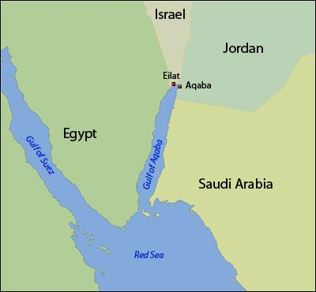
The encounter of Moses with God took place in a remote part of the desert and it’s not said why Moses happened to be there except perhaps he was drawn there for this divine appointment. Mt. Horeb or Mt Sinai as it is also known is in the southern part of the Sinai Peninsula across the Gulf of Aqaba from Midian which was on the western coast land of what is today Saudi Arabia. The suggestion is of a remote and strange somewhat mysterious place.
Midian
Mt Sinai
The Angel of the Lord who appears to him is recorded as appearing in several other places in the Old Testament and has a greater significance than simply an angel. Some commentators believe the Angel of the Lord to be a pre incarnate appearance of Jesus. Either way he is a special ambassador set from God but here if you notice it is God who speaks from the bush. That may be significant in identifying the Angel of the Lord.
Fire is significant and symbolic of God’s presence in the whole of the bible but it is particularly so in the book of Exodus. On the day of Pentecost when the Holy Spirit filled the believers tongues of fire also rested on them.
Bear in mind that Moses fled Egypt as a wanted man. He had now been in the desert tending the sheep of his father in law for 40 years. Whether he had a personal faith in Yahweh (God) is a debatable point, and it’s not told to us how much he knew of God, shared or remembered of the faith of Israel.
God speaks his name in verses 11 & 14 though in a way its meaning is too deep for us to fully understand. It is a form of the Hebrew verb meaning “to be” and has 4 letters which in English are YHWH but since Hebrew didn’t have any vowels its pronounced as Yahweh in English and usually written as LORD (in capitals) in our English bibles.

The figure of Moses as the mediator between God and Israel (God’s people) prefigures Jesus the Mediator between God and man. He is the one who leads Israel out of bondage and delivers them to the promised land. Jesus delivers his people from another type of bondage; the bondage to sin and bring them into freedom and the presence of God.

DISCUSSION QUESTIONS
Have you ever seen an amazing sight perhaps a sunset or something like that which made you stand in awe and through which perhaps God spoke into your life or situation? Share your experiences.
EXODUS 3
- Moses was told to take his sandals off a practice still common in the middle east when entering a holy place. What made this particular place Holy?
- How did God first identify himself to Moses, and what does that say about God and suggest about the individuals named in verse 6?
- What do verses 7 – 10 tell us about the nature of God?
- Called to such a task you would imagine that Moses should be confident, but what is his response (V11) and why do you think he responded in this particular way?
- Do you think it likely that we would react in a similar way to a call or commission from God and if so what emotions might lie at the root of our reaction?
- How does God respond in verse 12 and why should this be a reassurance to Moses?
- Considering the magnitude of the task given to Moses how is the assurance given by God an encouragement to us when called to a particular task? (see also 2 Corinthians 12:7-10)
- What steps do you think are crucial in exploring and following through a sense of call? (i.e. is it prayer, seeking confirmation from the bible, advice, the opinion of friends etc, etc.)
- What do you think the name “I AM” tells us about God and how should that influence our worship and faith?
- Bearing in mind the motto of our denomination “Ardens Sed Virens” in English meaning “burning yet flourishing” do you think it accurately describes our Presbyterian church today? Give reasons for and discuss your answer.

