Discipleship Groups Study
1st Samuel ch 3
“God breaks his silence”

Read 1st Samuel chapters 1-3 in preparation for the study.
The events of the early part of 1st Samuel take place towards the end of the Judges period in Israel between 1380 & 1050BC.
Samuel’s birth had a miraculous aspect as did Isaac’s earlier (to Abraham & Sarah), and John the Baptist’s later (to Zachariah & Elizabeth) but it is interesting that these all seem to come at significant times in the unfolding of God’s revelation or salvation story. These were times in which God was doing something new.
As a boy Samuel was in training under Eli the priest as he (Samuel) ministered before the Lord at the shrine in Shiloh which is in the central part of Israel. However once called by God Samuel was attested as a prophet and recognised by all Israel from Dan in the north to Beersheba in the south
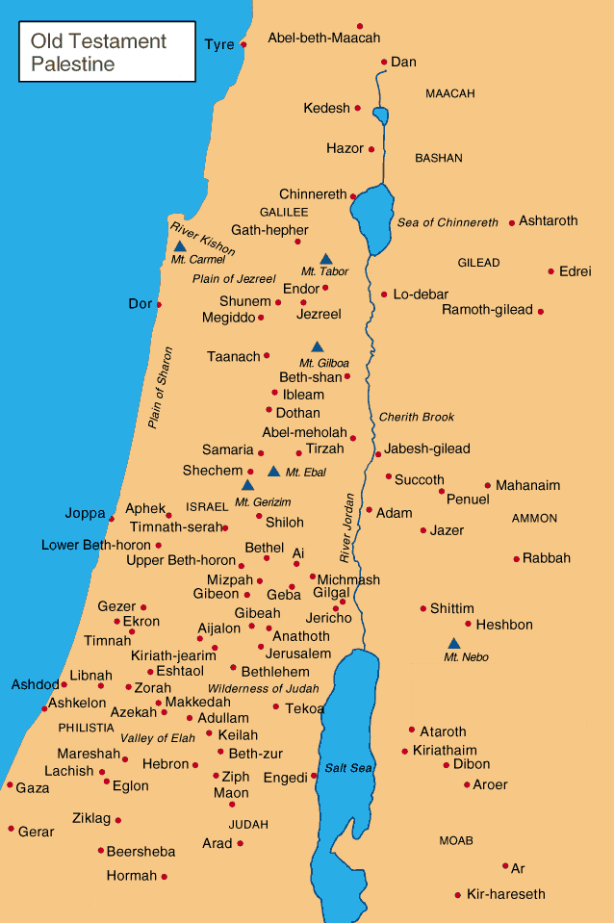
He was leader of Israel in the transition from Judges to a monarchy and was pivotal in that role anointing both Saul and David as kings to be at God’s command.
Samuel’s call marks the end of a silence in which God did not speak or reveal himself, or at least as the text says “In those days the word of the Lord was rare; there were not many visions.” This absence of visions and silence on God’s part most likely represented God’s judgement on Israel which strayed frequently in the Judges period. Eli’s sons were typical. They were corrupt and unrighteous in their way of life. They took their pick of the offerings brought by worshippers as sacrifices, disregarding the law in respect of how these offerings should be treated and presented to God and they were immoral sleeping with the women who served at the Tent of Meeting. Samuel’s first task was to announce the coming of God’s judgement on Eli and his household. Not an easy task for a youth given his apparent fondness for old Eli.
If you want to you can listen again to the sermon from last Sunday on the church website

Questions for discussion.
Have you ever been waiting for a letter message or call from someone and it was slow to come or never materialised. Describe how you felt; what were your thoughts or perhaps your fears?

- From your background reading of the first three chapters can you find any evidence that the absence of God’s voice in the nation of Israel caused any concern? What reaction would you normally expect from the people of God to such a silence?

- What was the message given to Samuel (verse 12)?

- Why do you think Samuel was afraid to announce this message? (verse 15)

- Are there times when as the church or as individual Christians we need to bring a difficult message to others and if so why would we be reluctant to bring it?

- What do Samuel’s actions teach us about faithfulness to the truth?

- What do you think of Eli’s reaction to the prophecy? (verse 18)

- Do you think the voice of God is heard in the church today? Give reasons for your answer and discuss what response you think is appropriate in the church.

- Do you think that the voice of God is heard in our nation today; for instance does the church bring a message from God? (Sometimes this is described as having a prophetic voice or message).

- If not what reasons or factors might explain why the church is silent?

- How can we as individual believers be useful to God today?

